**Robotics – Assignment 1**

The environment displayed is a 33 by 33 square grid. The blue node represents the start node and the green node represents the goal node. The red color represents the nodes and edges traversed in order to get from the start node to the goal node. The heuristic function used for the A* star algorithm was the straight-line distance between the current node and the goal node.

**Pair 1**: Start Index: (0,0) Goal Index: (32,32)

**DFS**

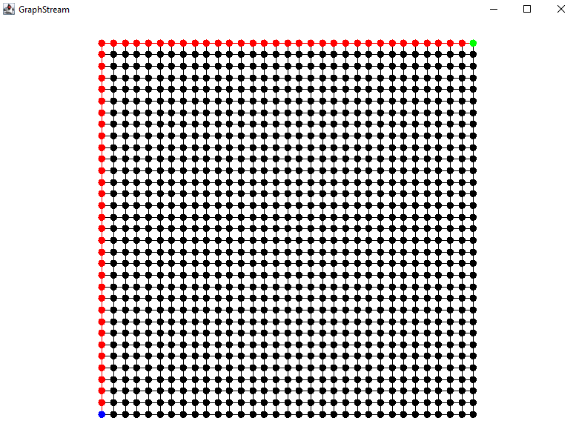

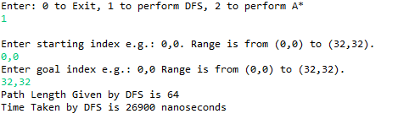

**A\***

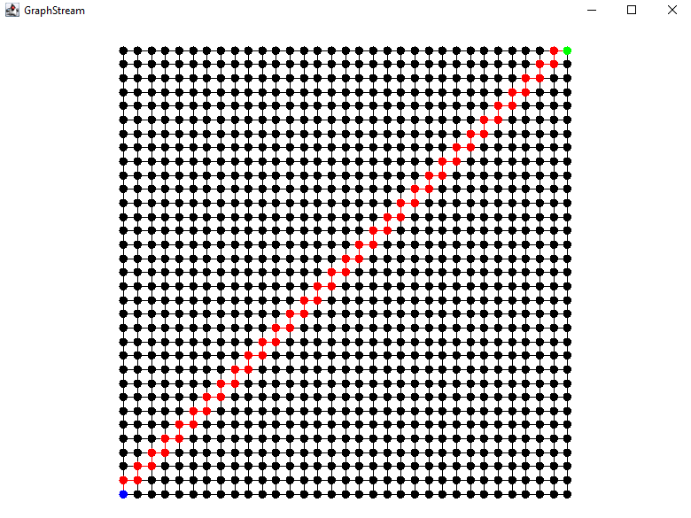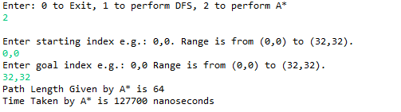

**Pair 2**: Start Index: (0,0) Goal Index: (32,0)

**DFS**

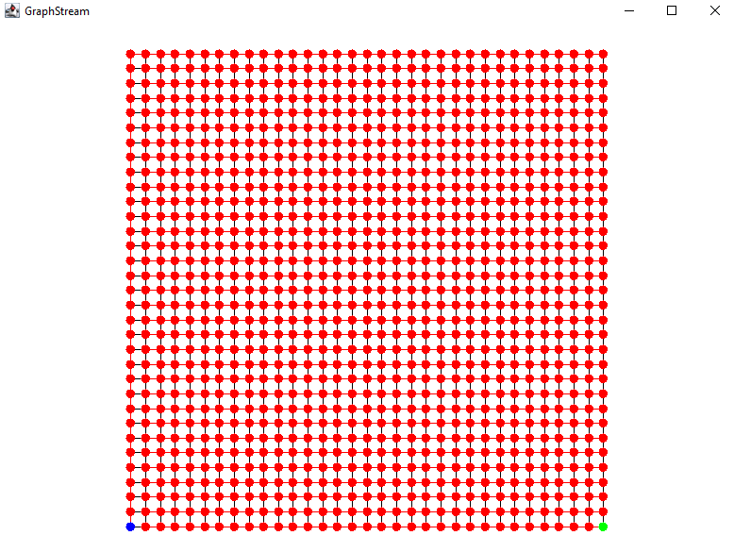

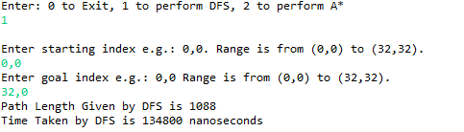

**A\***

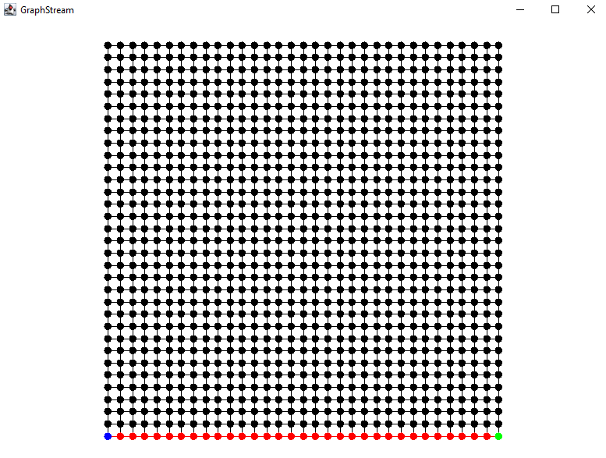

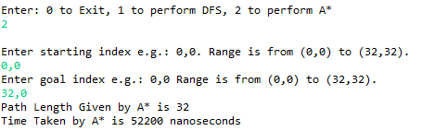

**Pair 3**: Start Index: (3,8) Goal Index: (27,21)

**DFS**

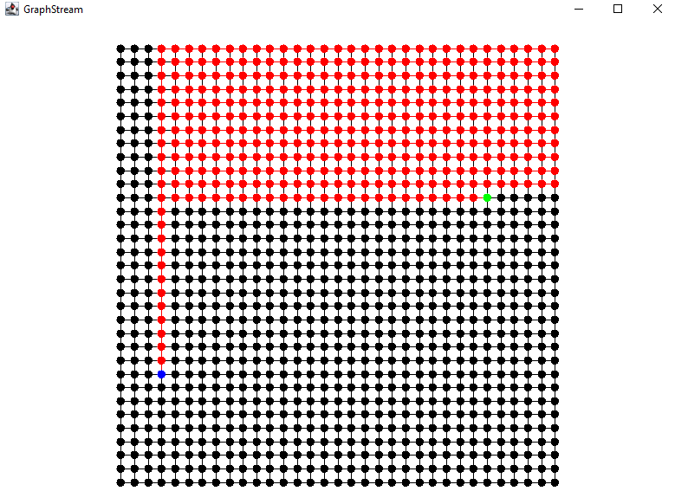

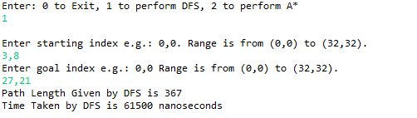

**A\***

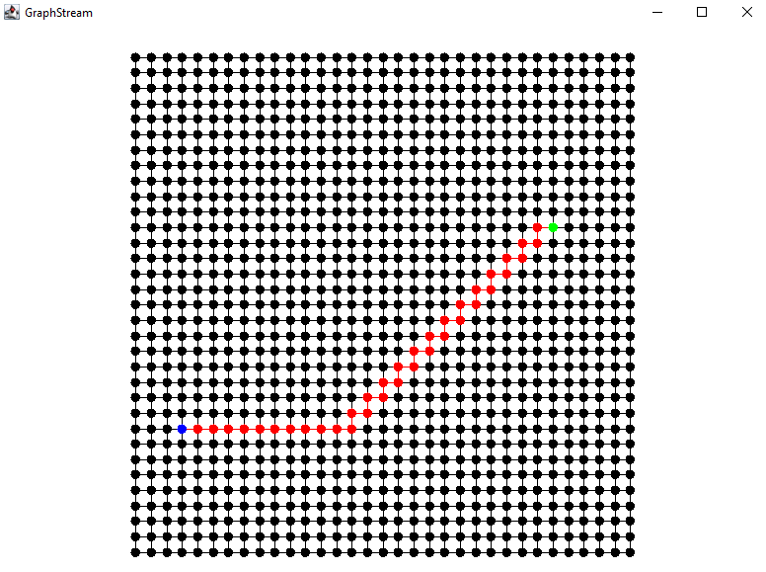

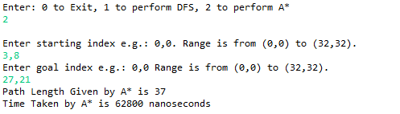

**Pair 4**: Start Index: (5,30) Goal Index: (29,1)

**DFS**

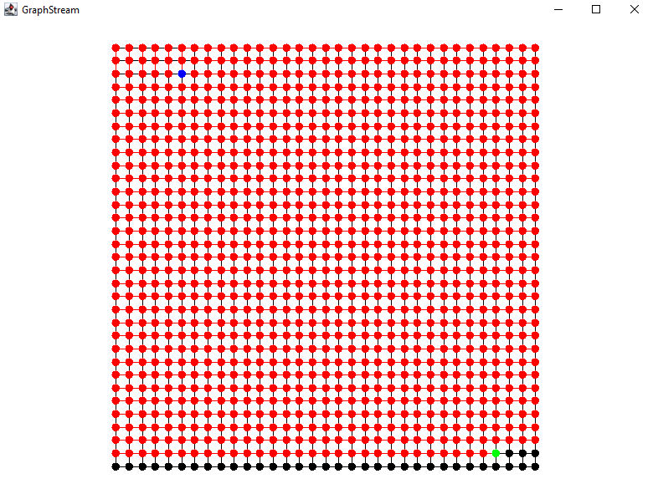

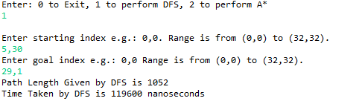

**A\***

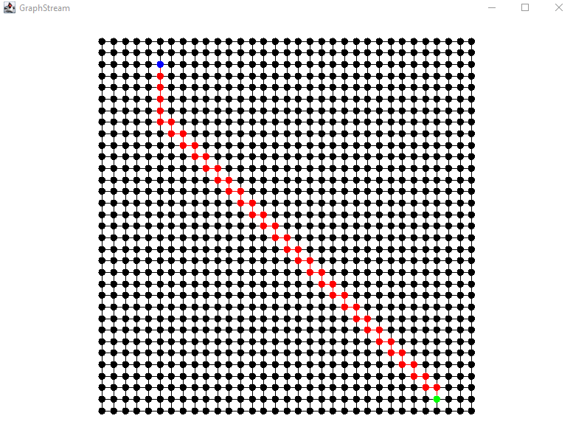

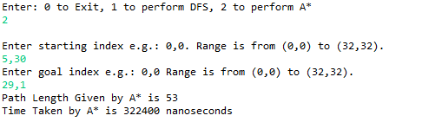

**Pair 5**: Start Index: (19,29) Goal Index: (30,7)

**DFS**

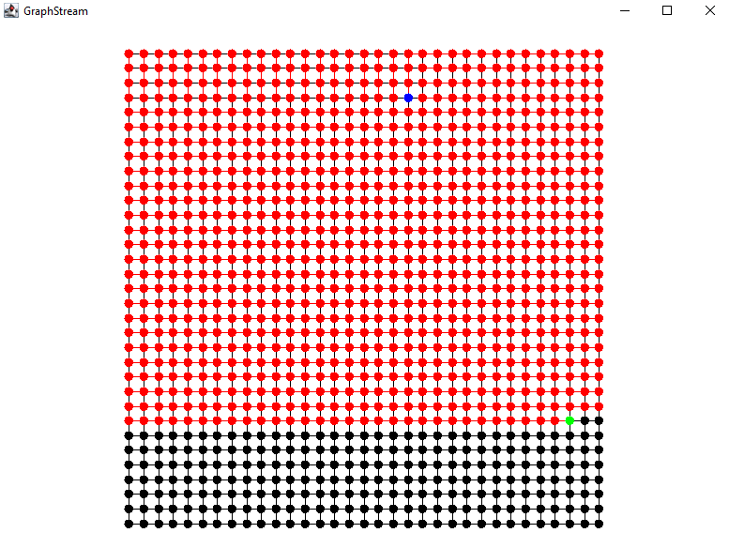

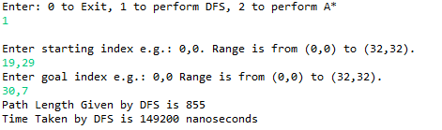

**A\***

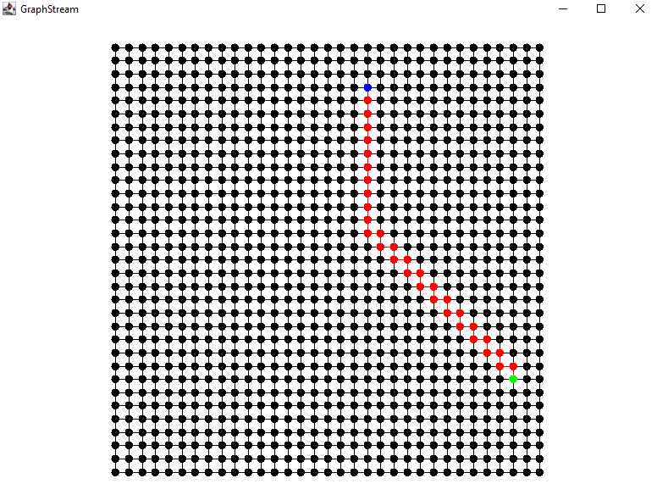

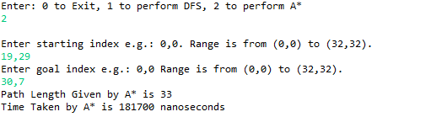

**Pair 6**: Start Index: (7,11) Goal Index: (24,24)

**DFS**

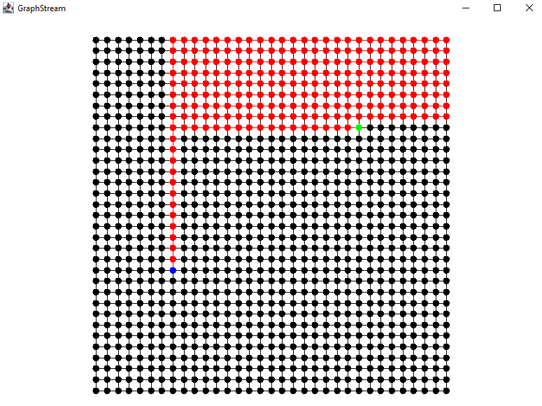

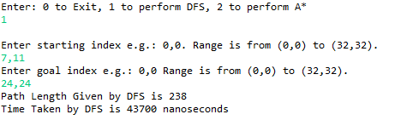

**A\***

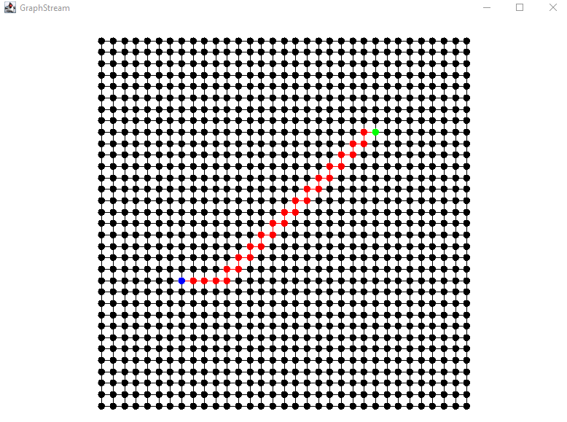

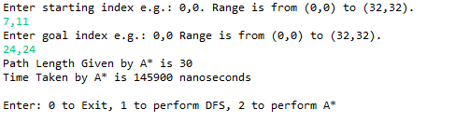

**Pair 7**: Start Index: (9,18) Goal Index: (24,18)

**DFS**

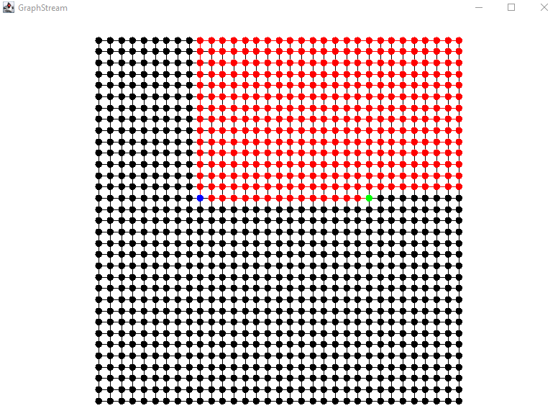

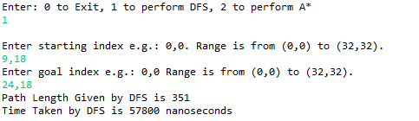

**A\***

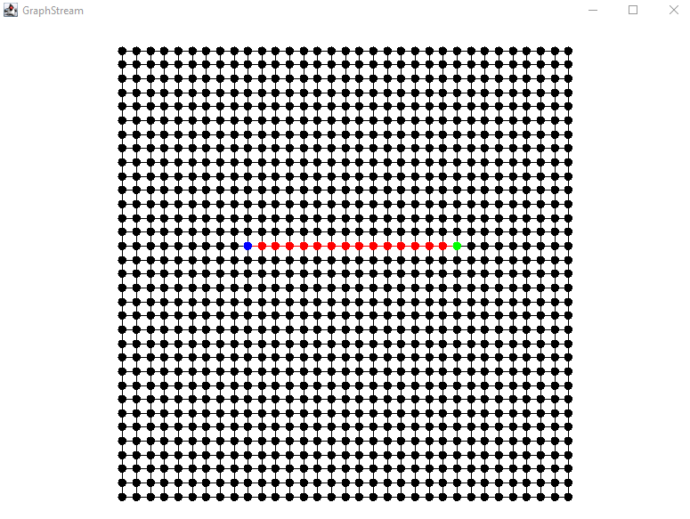

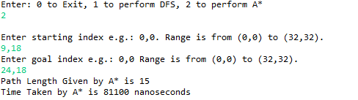

**Pair 8**: Start Index: (15,5) Goal Index: (15,25)

**DFS**

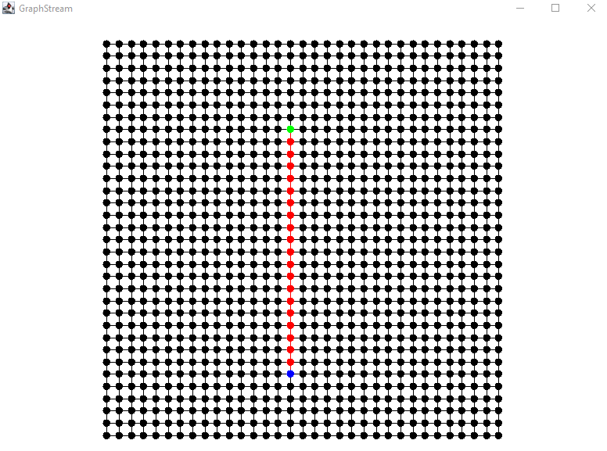

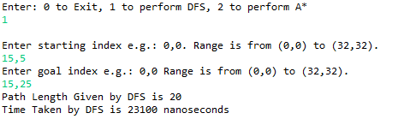

**A\***

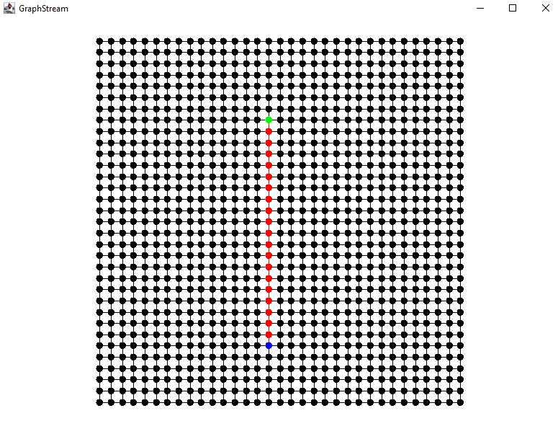

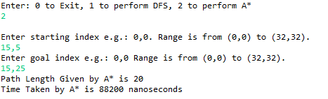

**Pair 9**: Start Index: (2,9) Goal Index: (22,11)

**DFS**

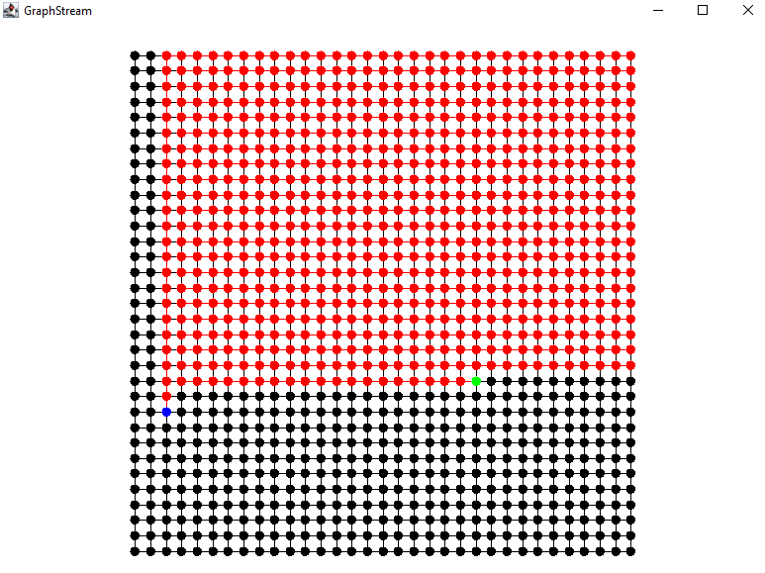

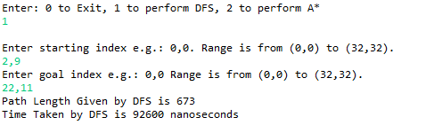

**A\***

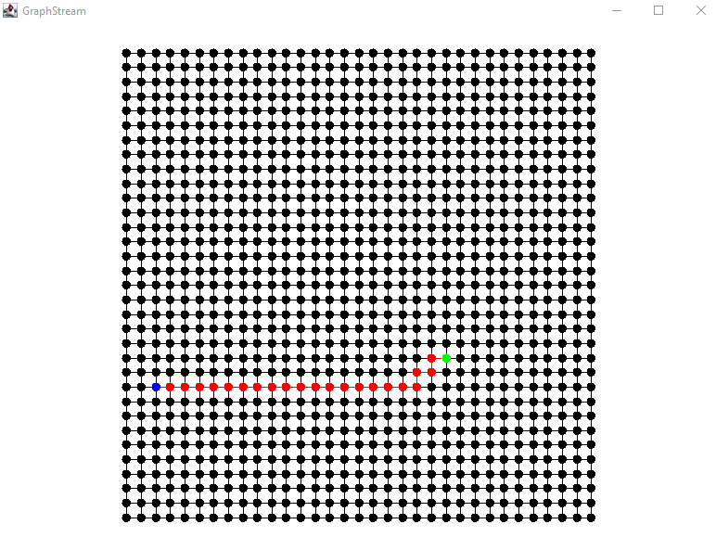

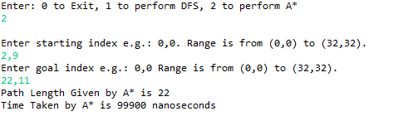

**Pair 10**: Start Index: (2,32) Goal Index: (27,0)

**DFS**

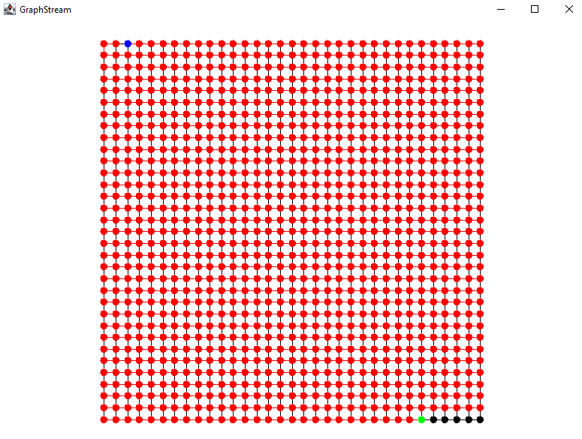

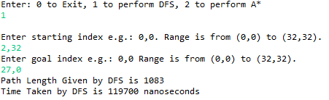

**A\***

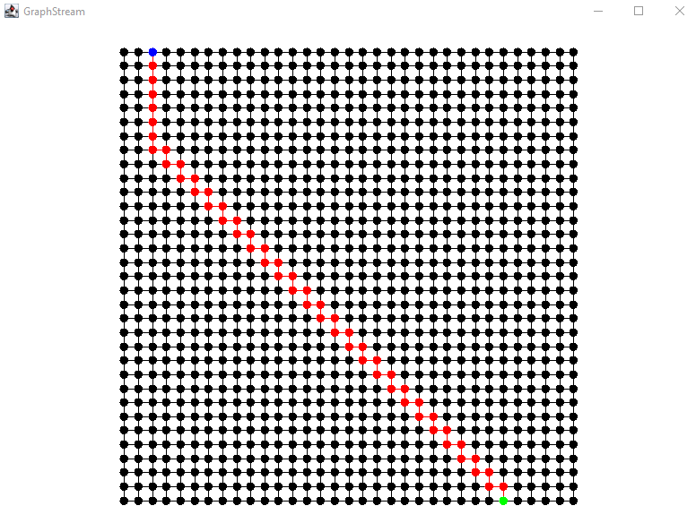

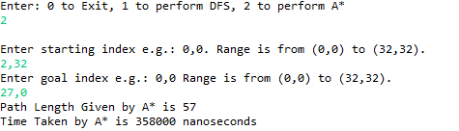

The average path length given by DFS is 579.1.

The average path length given by A* is 36.3.

The average time take by DFS is 82,890 nanoseconds.

The average time take by A* is 151,990 nanoseconds.